Case 13-US-NY-Erie Co.-Pipe-Monitor-Small-Deeply Curved Platform-Hopewell, Castle Creek Focus-c 250 CE

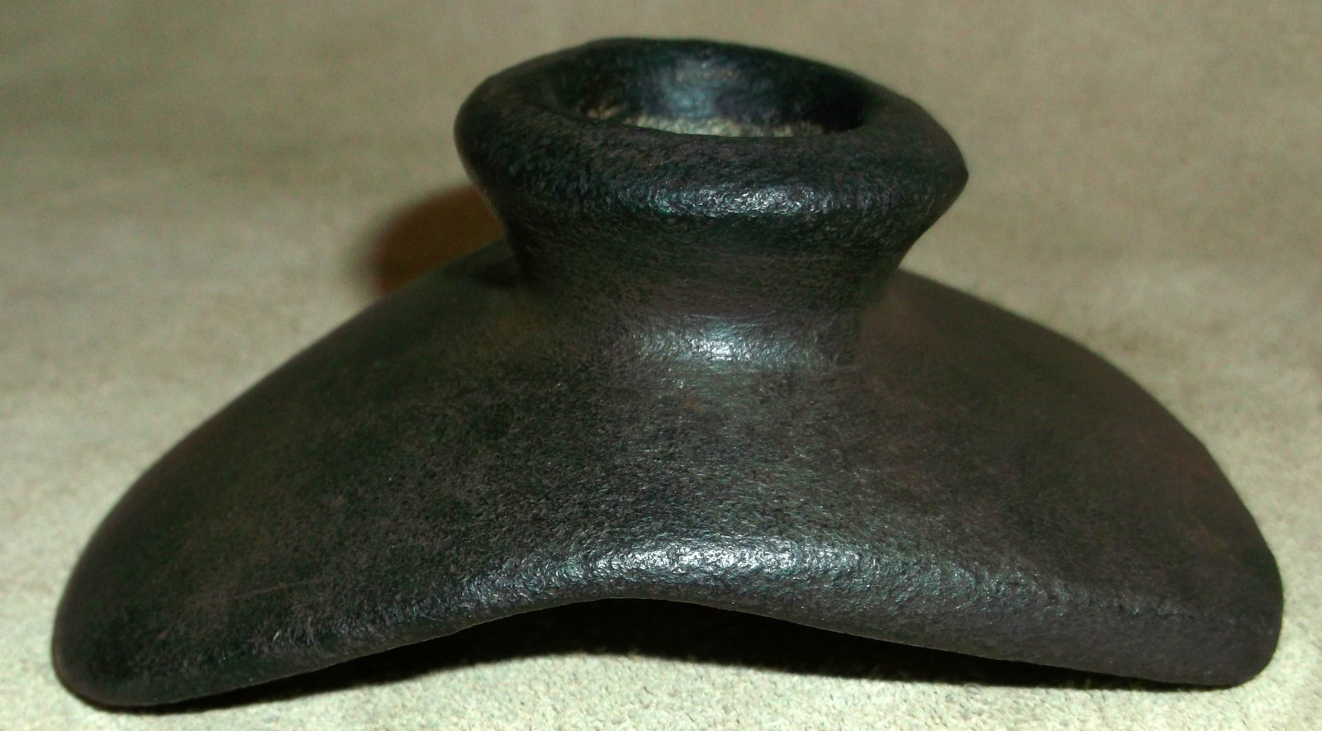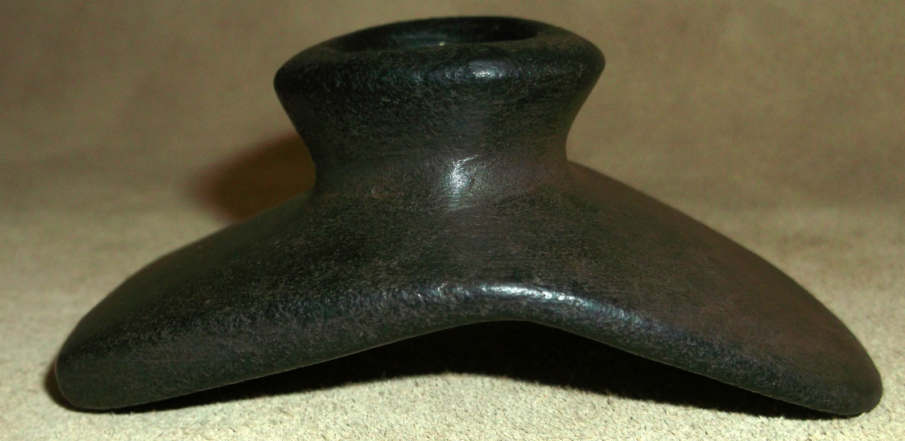

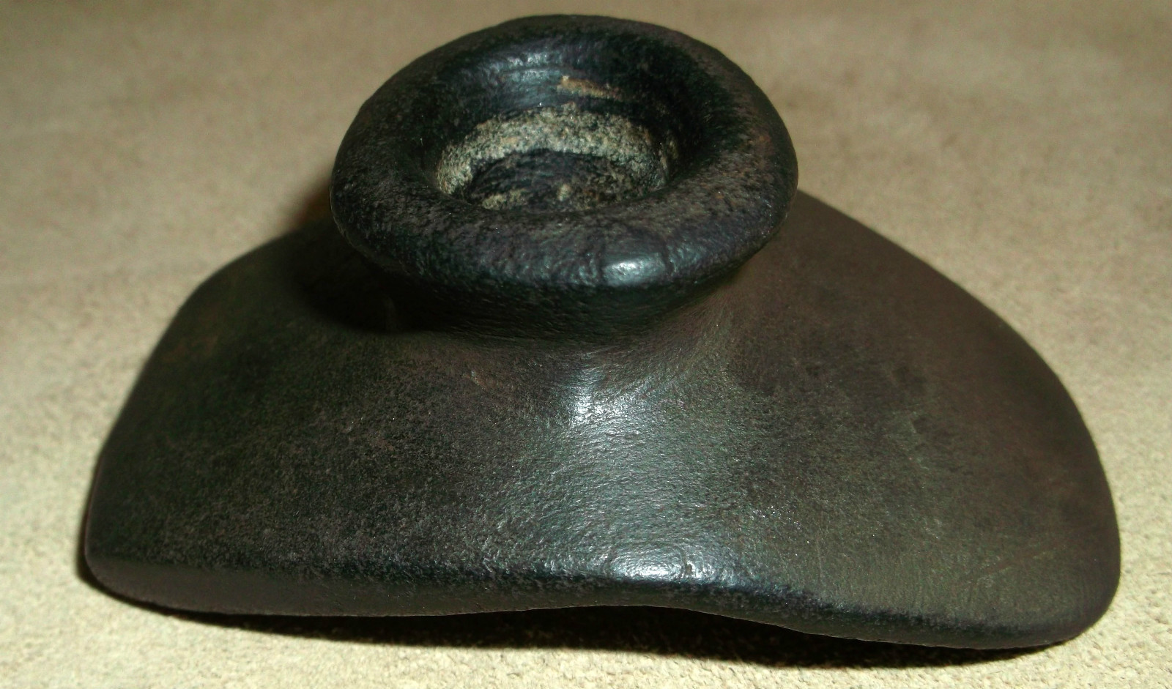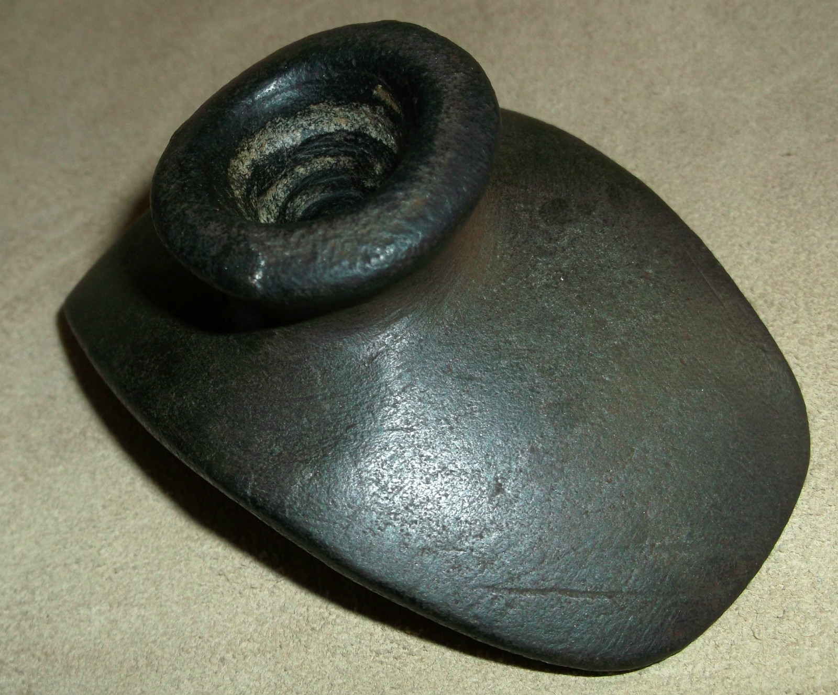

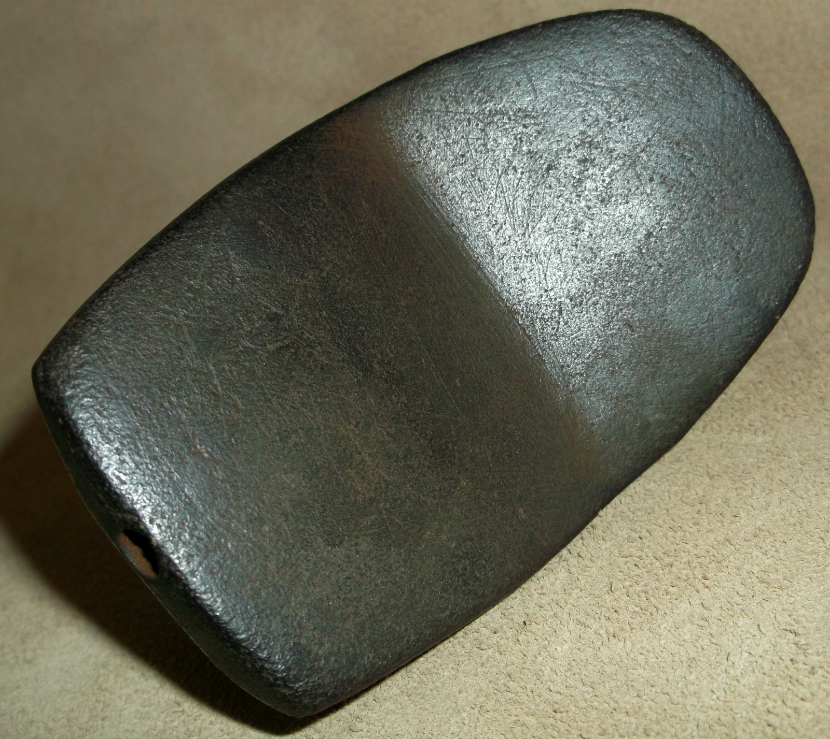 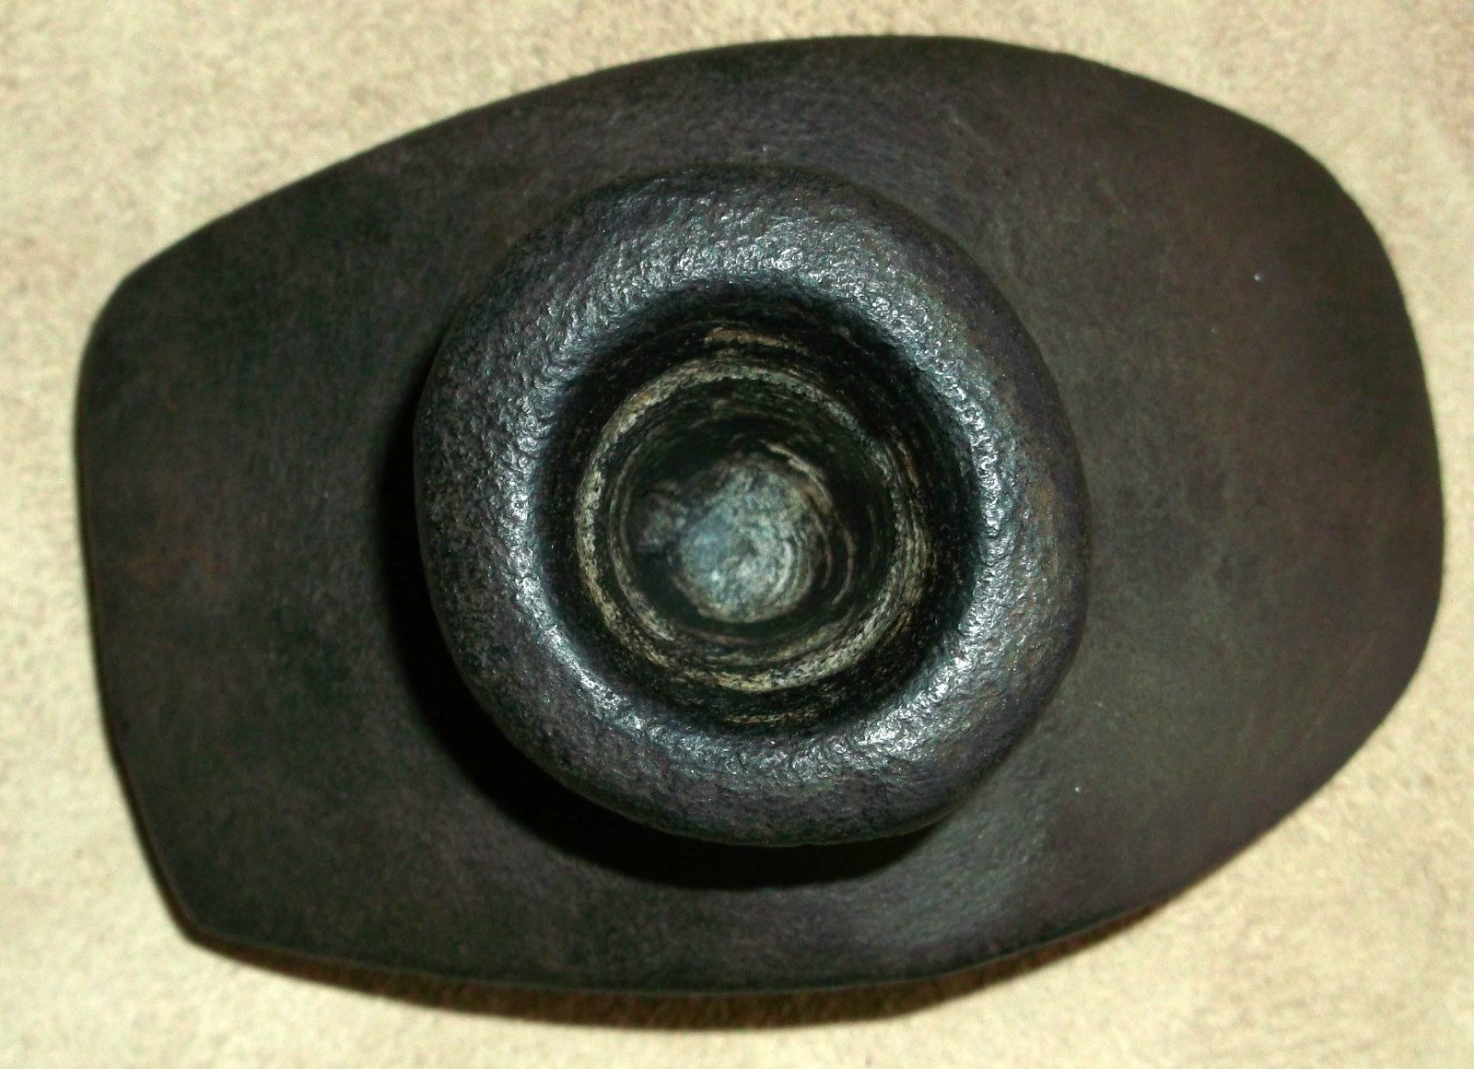

Figs. 1-6. US-NY-Erie Co.-Pipe-Monitor-Small-Deeply Curved Platform-Hopewell, Castle Creek Focus-c 250 CE

Case no.: 11

Accession Number:

Formal Label: US-NY-Erie Co.-Pipe-Monitor-Small-Deeply Curved Platform-Hopewell, Castle Creek Focus-c 250 CE

**Display Description:**

This is a diminutive Hopewell Monitor pipe which may have been used with a small copper tube mouthpiece. This is similar to one of the mound pipes collected by New York State archaeologist Kenneth Palmer from the Owasco Aspect, Castle Creek Focus in Erie County, which he noted as having a green stain on the inside of the stem as though from a copper residue (Ritchie 1944: 150).

**LC Classification:**

Date or Time Horizon: c 250 CE

Geographical Area: NY-Erie Co. **Castle Creek** is a [hamlet](https://en.wikipedia.org/wiki/Hamlet_(New_York)) in [Broome County](https://en.wikipedia.org/wiki/Broome_County,_New_York), [New York](https://en.wikipedia.org/wiki/New_York_(state)),

**Map:**

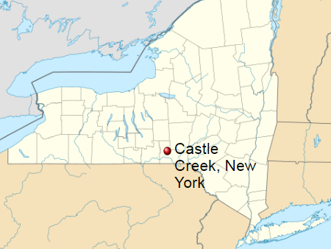

**Location of Castle Creek after https://upload.wikimedia.org/wikipedia/commons/thumb/8/8d/USA_New_York_location_map.svg/500px-USA_New_York_location_map.svg.png**

**GPS coordinates:** [42°13′39″N 75°55′06″W](https://tools.wmflabs.org/geohack/geohack.php?pagename=Castle_Creek,_New_York&params=42_13_39_N_75_55_06_W_region:US-NY_type:city)

Cultural Affiliation: Owasco Aspect, Castle Creek Focus (Ritchie 1938, Table 1)

Media:

Dimensions: Size: 3 9/16 inches long, 1 1/2 inches tall and the platform is 2 1/4 inches across.

Weight:

Condition:

Provenance:

**Discussion: From Ritchie 1938:98-100.**

THE OWASCO ASPECT Apparently partly coextensive in its later stage with the Iroquois occupation was a Woodland culture which constituted the dominant occupation of much of the Northeast for an unknown period prior to the Iroquois invasion. Its source, range and affinities with older manifestations in the area are largely matters for future research; nevertheless, with respect to implemental congeries and general configuration, the Owasco Aspect is one of the best elaborated in the whole area. Al- though reminiscent of Iroquois culture with respect to bone and stone work, the fundamental dichotomy in ceramics indicates different origins for the Iroquois and Owasco aspects. The known distribution embraces the whole central portion of New York State from the Genesee River eastward to the Hudson, with one recognized site in the north-central part (Jefferson County), and small stations on both sides of the Champlain Valley in New York and Vermont. The Delaware Valley in southeastern New York, Pennsylvania, and upper New Jersey, and the Susquehanna Valley, at least as far south as the West Branch in Pennsylvania, contain numerous camp and village sites. On the basis of pottery development two foci, presumably indicative of a temporal sequence, have been differentiated, viz., the Canandaigua and the Castle Creek. The stone and bone industries of both are in- distinguishable and the basic pipe form (obtuse-angle elbow type) re- mains constant. The essential differences concern the pottery vessels which in a large proportion of Canandaigua specimens have a conoidal base, slightly everted collarless rim, and are of coarser texture and more rudely embellished than is the case with Castle Creek ware. All known examples of the latter are characterized by a rounded bottom and the frequent presence of an incipient or well-defined collar, often bearing nodes or bosses and surmounted by rim points or castellation the decorative motifs of both groups are fundamentally of the same order, being simple combinations of herringbone and other rectilinear line complexes impressed with denticulated or cord-wrapped stamps, applied to neck and rim, Castle Creek vessels exhibit predominantly more meticulous workmanship, greater originality and variety of design, and not infrequent rude and bold incising on the vessel neck. This latter decorative innovation contrasts strikingly with the finely achieved pointille work on the same vessel, the product of long tradition and experience, and constitutes, together with the rounded base, well constricted neck, collar, rim points, and nodes, all features of Iroquois ceramics, the stylistic considerations on which Iroquois-Castle Creek connections are predicated.45 They are rarely present, and then in small degree, in the antecedent ware of the Canandaigu Focus.

…

Considered in toto, the Owasco Aspect is characterized by camp, village, and workshop sites indicative of a relatively numerous population with an agricultural economy. Carbonized corn and beans have been found in components of both foci. The settlements, like those of the Iroquois, were sometimes on hilltops a mile or more from a lake or large stream, and one station seems to have been stockaded. Floor outlines of small, round, pole-supported lodges with central fireplace have been found at one component. Refuse-filled cache pits are abundant on some sites, rare on others. Few cemeteries have been located, but these have consistently produced skeletons flexed in varying degrees, only rarely accompanied by grave goods, chiefly pipes.

46 Ritchie, 1934, pp. 45-46, 50. 46 See the following publications for the trait inventory as known: Parker, 1920, pp. 340-343; Ritchie, 1928; 1932 a, pp. 413-414; 1934; 1936; 1938, pp. 80-84

There remains to be considered the probable ethnic identity of the Owasco Aspect and its wider affinities. While archaeological proof is still lacking, there is actually little reason to doubt its Algonkian provenience, and while all stations thus far discovered pertain to the prehistoric horizon, future excavations may disclose a protohistoric site enabling correlation with some historic tribe or tribes of this people.

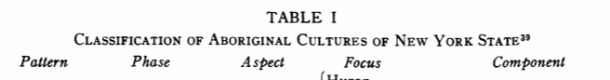

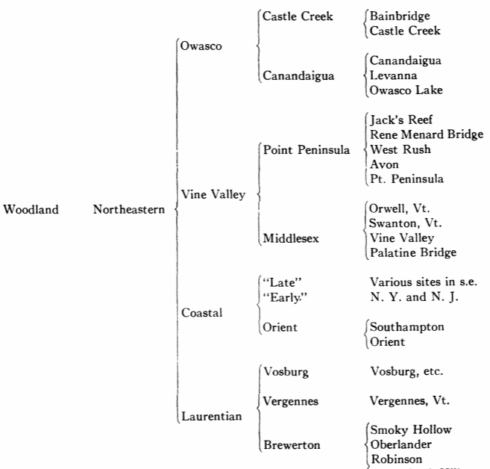

**References:**

Ritchie, William A. 1938. “A Perspective of Northeastern Archaeology,” *American Antiquity*, (4:2, Oct.): 94-112.

Ritchie, William A. 1944. *The pre-Iroquoian occupations of New York State*. Rochester: Rochester Museum of Arts and Sciences.

ABBOTT, CHARLES C. 1881. Primitive Industry. Salem, Mass. 1888. Evidences of the Antiquity of Man in Eastern North America. Proceedings, American Association for the Advancement of Science, Vol. 37, Salem, Mass.

BUTLER, MARY. 1937. Three Sites in Somerset County, Pennsylvania. Unpublished manuscript.

COLE, FAY-COOPER, and THORNE DEUEL. 1937. Rediscovering Illinois, University of Chicago Press.

DEUEL, THORNE. 1935. Basic Cultures of the Mississippi Valley. American Anthropologist, Vol. 37, No. 3, Pt. 1.

FERGUSON, ALICE L. L. 1937. Moyaone and the Piscataway Indians. Privately printed, Washington, D. C.

GREENMAN, EMERSON F. 1937. The Younge Site. Occasional Contributions from the Museum of Anthropol- ogy of the University of Michigan, No. 6.

HARRINGTON, M. R. 1909. Ancient Shell Heaps near New York City. (In) The Indians of Greater New York and the Lower Hudson, Anthropological Papers, Vol. 3, American Museum of Natural History, New York.

HARRINGTON, M. R. 1909a. The Rock-Shelters of Armonk, New York. (In) The Indians of Greater New York and the Lower Hudson, Anthropological Papers, Vol. 3, American Mu- seum of Natural History, New York.

HARRINGTON, M. R. 1924. An Ancient Village Site of the Shinnecock Indians. Anthropological Papers, American Museum of Natural History, Vol. 22, Pt. 5, New York.

HAWKES, E. W. and RALPH LINTON. 1916. A Pre-Lenape Site in New Jersey. Anthropological Publications, University of Pennsylvania, Vol. 6, No. 3.

HOLMES, W. H. 1903. Aboriginal Pottery of the Eastern United States. 20th Annual Report, Bu- reau of American Ethnology, Smithsonian Institution, for 1898-99, Washing-ton, D. C.

HOUGHTON, FREDERICK B. 1927. The Migrations of the Seneca Nation. American Anthropologist, Vol. 29, No. 2.

JENNESS, DIAMOND. 1925. A New Eskimo Culture in Hudson Bay. Geographical Review, Vol. 15, No. 3.

KEYES, CHARLES REUBEN. 1934. Antiquities of the Upper Iowa. The Palimpsest, October, State Historical Society of Iowa, Iowa City. 110 [2, 1938 This content downloaded from 18.9.61.112 on Mon, 08 Oct 2018 20:36:58 UTC All use subject to <https://about.jstor.org/terms>

MERCER, HENRY C. 1897. Researches Upon the Antiquity of Man in the Delaware Valley and the Eastern United States. Pub. of the University of Pennsylvania, Series in Philology, Literature and Archaeology, Vol. 6.

MERCER, HENRY C. 1898. A New Investigation of Man's Antiquity at Trenton. Proceedings, American Association for the Advancement of Science, August, 1897, Salem.

MOOREHEAD, WARREN K. 1922. Archaeology of Maine. Phillips Academy, Andover, Mass.

PARKER, ARTHUR C. 1916. The Origin of the Iroquois as Suggested by their Archeology. American Anthropologist, Vol. 18.

PARKER, ARTHUR C. 1920. The Archeological History of New York. Bulletins of the New York State Museum, Nos. 235, 236, Albany, New York.

RITCHIE, WILLIAM A. 1928. An Algonkian Village Site at Levanna, Cayuga County, New York. Research Records, No. 1, Rochester Museum of Arts and Sciences, Rochester, New York.

RITCHIE, WILLIAM A. 1932. The Lamoka Lake Site, the Type Station of the Archaic Algonkin Period in New York. Researches and Transactions of the New York State Archeological Association, Vol. 7, No. 4, Rochester, New York.

RITCHIE, WILLIAM A. 1932a. The Occurrence of Multiple Bony Lesions Suggesting Myeloma in the Skeleton of a Pre-Columbian Indian. American Journal of Roentgenology and Radium Therapy; Vol. 28, No. 5 (with Stafford L. Warren, M.D.).

RITCHIE, WILLIAM A. 1932b. The Algonkian Sequence in New York. American Anthropologist, Vol. 34, No. 3.

RITCHIE, WILLIAM A. 1934. An Algonkin-Iroquois Contact Site on Castle Creek, Broome County, New York. Research Records, No. 2, Rochester Museum of Arts and Sciences, Rochester, New York.

RITCHIE, WILLIAM A. 1936. A Prehistoric Fortified Village Site at Canandaigua, Ontario County, New York. Research Records, No. 3, Rochester Museum of Arts and Sciences, Rochester, New York.

RITCHIE, WILLIAM A. 1936a. Indian Mounds in the Genesee Valley. Museum Service, Rochester Museum of Arts and Sciences, November.

RITCHIE, WILLIAM A. 1936b. New Evidence Relating to the Archaic Occupation of New York. Researches and Transactions of the New York State Archeological Association, Vol. 8, No. 1, Rochester, New York.

RITCHIE, WILLIAM A. 1937. A New Archaeological Culture in New York. Museum Service, Rochester Museum of Arts and Sciences, November.

RITCHIE, WILLIAM A. 1937a. Culture Influences from Ohio in New York Archaeology. American Anti- quity, Vol. 2, No. 3.

RITCHIE, WILLIAM A. 1938. A Unique Prehistoric Workshop Site. Museum Service, Rochester Museum of Arts and Sciences, April.

RITCHIE, WILLIAM A. 1938a. Certain Recently Explored New York Mounds and their Probable Relation to the Hopewell Culture. Research Records, No. 4, Rochester Museum of Arts and Sciences, Rochester, New York.

SKINNER, ALANSON. 1909. The Lenape Indians of Staten Island. (In) The Indians of Greater New York and the Lower Hudson, Anthropological Papers, Vol. 3, American Museum of Natural History, New York. 11I This content downloaded from 18.9.61.112 on Mon, 08 Oct 2018 20:36:58 UTC All use subject to https://about.jstor.org/terms AMERICAN ANTIQUITY

SKINNER, ALANSON. 1909a. Archaeology of Manhattan Island. (In) The Indians of Greater New York and the Lower Hudson, Anthropological Papers, Vol. 3, American Museum of Natural History, New York.

SKINNER, ALANSON. 1909b. Archaeology of the New York Coastal Algonkin. (In) The Indians of Greater New York and the Lower Hudson, Anthropological Papers, Vol. 3, American Museum of Natural History, New York.

SKINNER, ALANSON. 1915. The Indians of Manhattan Island and Vicinity. Guide Leaflet Series, No. 41, American Museum of Natural History, New York.

SKINNER, ALANSON. 1915a. Chronological Relations of Coastal Algonquian Culture. Proceedings, Nine- teenth International Congress of Americanists, Washington, D. C.

SKINNER, ALANSON. 1919. Exploration of Aboriginal Sites at Throgs Neck and Clasons Point, New York City. Contributions from the Museum of the American Indian, Heye Foundation, No. 4, New York.

SKINNER, ALANSON. 1920. Archeological Investigations on Manhattan Island, New York City. Indian Notes and Monographs, Vol. 2, No. 6, Museum of the American Indian, Heye Foundation, New York.

SKINNER, ALANSON. 1921. Notes on Iroquois Archeology. Indian Notes and Monographs, No. 18, Museum of the American Indian, Heye Foundation, New York.

SPIER, LESLIE. 1918. The Trenton Argillite Culture. Anthropological Papers of the American Museum of Natural History, Vol. 22, Pt. 4, New York.

VOLK, ERNEST. 1911. The Archaeology of the Delaware Valley. Papers, Peabody Museum, Vol. 5, Cambridge.

WILLOUGHBY, CHARLES C. 1898. Prehistoric Burial Places in Maine. Papers of Peabody Museum of American Archaeology and Ethnology, Harvard University, Cambridge.

WILLOUGHBY, CHARLES C. 1915. The "Red Paint People" of Maine. American Anthropologist, Vol. 17.

WILLOUGHBY, CHARLES C. 1935. Antiquities of the New England Indians. Peabody Museum of American Archaeology and Ethnology, Harvard University, Cambridge.

WINTEMBERG, W. J. 1928. Artifacts from Ancient Graves and Mounds in Ontario. Proceedings and Transactions, 3rd Series, Vol. 22, Royal Society of Canada, Ottawa.

Appendix: order Hidden

| Shipping details |
| --- |
| **Ralph J Coffman Jr**  149 Atlantic Ave  Swampscott MA 01907-2427  United States |

## Order details

|  |  |  |  |  |  |
| --- | --- | --- | --- | --- | --- |
|  | **Item title** | | **Available actions** | **Shipping & handling (estimated delivery*)** | **Price** |
| Seller: | | [**Member id** claws-teeth-bones](http://myworld.ebay.com/claws-teeth-bones) ( [**Feedback Score Of** 672](http://feedback.ebay.com/ws/eBayISAPI.dll?ViewFeedback&userid=claws-teeth-bones)) | | [Contact seller](http://contact.ebay.com/ws/eBayISAPI.dll?ShowCoreAskSellerQuestion&frm=3998&iid=0&redirect=0&requested=claws-teeth-bones) |  |

|  |  |  |  |  |
| --- | --- | --- | --- | --- |
| **Order # 123076218017**  Paid on Oct-29-12 via PayPal | | | | |
|  |  | |  | | --- | |  | | |  |  | | --- | --- | | [Contact seller](http://contact.ebay.com/ws/eBayISAPI.dll?ShowCoreAskSellerQuestion&frm=3998&iid=150928074714&redirect=0&requested=claws-teeth-bones) |  | | |  |  |

|  |  |  |  |  |  |  |  |
| --- | --- | --- | --- | --- | --- | --- | --- |
| [**Item Title:**Very Old, Rare Stone Arched Platform Indian Artifact Peace Pipe**- opens in a new window or tab**](http://cgi.ebay.com/ws/eBayISAPI.dll?ViewItem&item=150928074714)  **Item Id:**150928074714 - Price: US $212.50  Quantity:1  Having a problem with this purchase? [We can help](javascript:;) | |  | | --- | |  | | |  |  | | --- | --- | | [Leave feedback](http://feedback.ebay.com/ws/eBayISAPI.dll?LeaveFeedbackShow&useridfrom=802-867&useridto=claws-teeth-bones&item=150928074714&transactid=0) |  | | | Economy Shipping : **US $16.85**  USPS Parcel Post®  Estimated delivery: November 1 - November 8  **Package 1 of 1**    Shipment details: [9407809699938236570419](javascript:;) | US $212.50 |